***SOFTWARE DESIGN SPECIFICATION***

**Pharmacy Management System**

**Team 1 members:**

Sai Thejas Chillagatu Ramesh - 2837401

Veera Venkata Jagannadham Ganta-2833181

Rama Koteswara Rao Kolla - 2835029

Rajasekhar Gali - 2836153

1. **Introduction**

The Project name “**Pharmacy Management System**”, a medical information system is a client/server-based application.

An Interactive application for managing both stock and billing which helps in maintaining the records of the medicine, the users and store details and reduces the work of searching the medicine. The main aim of this application is to apply technology supporting the pharmacist and the store to reduce the human effort on searching and automation of the billing.

The project has been developed based on “Stock managing” and it’s “billing process” being presently used in the medical stores for storing and retrieving the available information in the store

* 1. **Goals and objectives**

# Goals

* Admin can login through the webpage.
* Admin can view the stock details.
* Inventory of medicines in the pharmacy can be inserted into the database.
* Admin can add new medicines and supplies.
* Admin can edit/delete stock details.
* Admin can enter customers and sales details.

# Objectives

* To easily maintain stocks in the pharmaceutical store.
* To keep track of sales.
* To keep track of medicines and their suppliers.
* To keep track of customer details**.**
* To reduce paperwork.

**1.2 Statement of scope**

This project aims at computerizing the manual process of authorized pharmaceutical dealers visiting the Outlets to buy drugs. Front-end are implemented using HTML, CSS and JavaScript and back end using MySQL and Php language.

Pharmacy management system allows store dealers to maintain a records of drugs available and unavailable. To keep track of sales and suppliers.

In traditional systems registers are used to keep track of day-to-day orders which are messy. In our system details of every vehicle is present in the database and can be accessed easily. Every detail is arranged in a structured way and in a secured way

**1.3 Software context**

* Database: phpMyAdmin
* User Interface: Google Chrome
* Server: XAMPP Server
* Front End Design: HTML
* Back End Design: php
* Code Developing Software: phpstorm

**2.0 Data design:**

The project is implemented using MySQL database along with PHP and HTML. In this project, we use the concepts below for implementing different type of effects like HTML pages to demonstrate on a web page as a stand-alone or web-based application. It is a three-tier architecture project. A three-tire architecture is a client-server architecture in which the functional process logic, data access, computer data storage and user interface are developed and maintained as independent modules on separate platforms. Three-tier architecture is software design pattern and a well-established software architecture.

**2.1 Data structures**

* Interaction with database.
* Extracting data from database.
* Storing information’s.
* Scripting language.
* Interpreter.
* HTML user interface.
* Stored procedures.
* Triggers.

**2.2 Database description**

In admin page we will have login Id so in this C_id is used as primary key. When the admin is logged in he used to insert the medicine id and medicine name and medicine description and next we will have suppliers in that the admin used to have whole data of the supplier like admin used to insert the supplier id and supplier name and the address of the supplier. Next if the admin use to check the stocks he need to enter the stock id and medicine id and supplier id in this how much quantity he supplied to the supplier and what stock is remaining in the go down and what’s the price of the medicine and what’s the date which is supplied to the supplier from the admin. Next about sales the admin use to enter the sales id and the stock id and the customer id and the quantity of the medicine like what the price of this quantity and what date does the admin supplied to the supplier.

* **Data Objects**

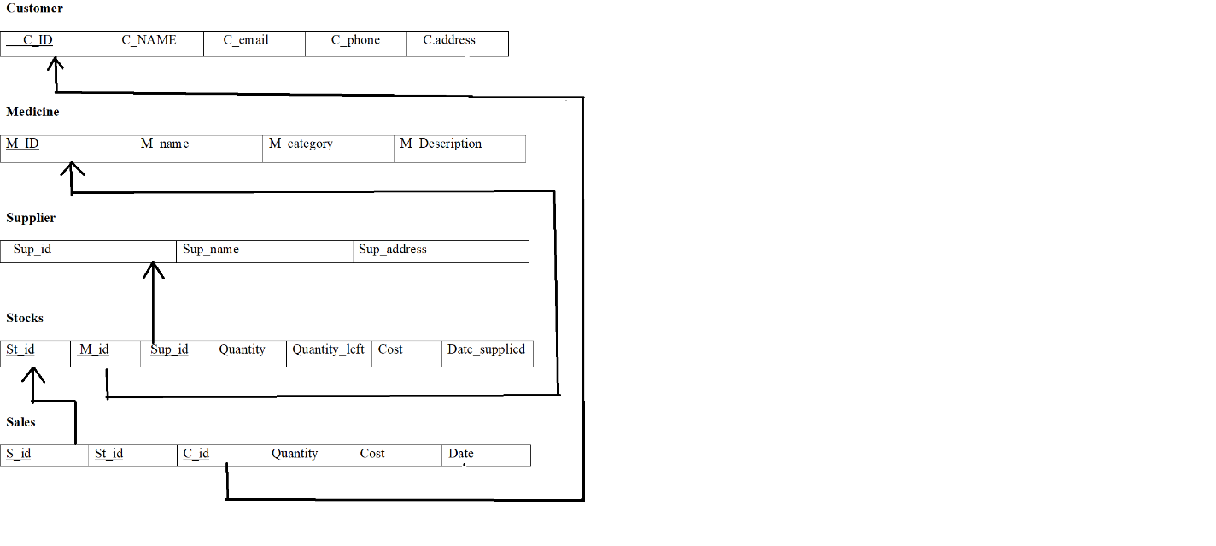

* **Relationships**

quantity_left

quantity

sup_id

c_phone

c_email

cost

m_id

c_address

c_name

Date_supplied

St_id

c_id

Buys From

Stocks

customer

Has

Does

Present In

Supplies

s_id

Supply

Suppliers

Medicine

Sales

st_id

m_id

m_description

Sup_address

sup_id

sup_name

c_id

M_category

cost

date

* **Complete data model**

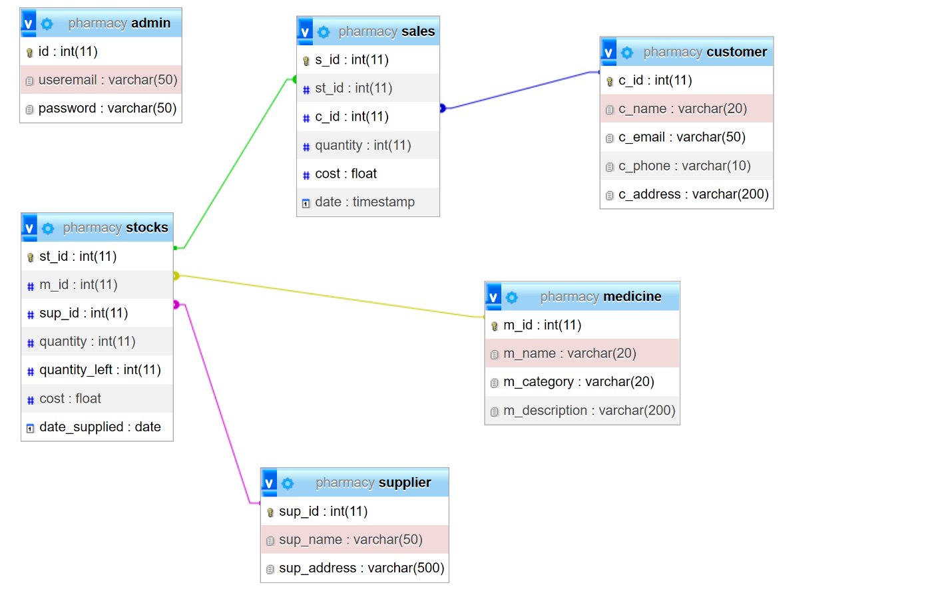

**3.0 Architectural and component-level design**

**3.1 Architecture diagrams**

Apache

MySQL Server



XAMPP

Server

Interanet

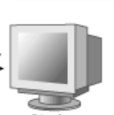 



**User Interface**

**3.2 Description for Components**

The components that are used in this project implementation are:

* Xampp Server
* MySql
* Apache

**Xampp server:**

Xampp is a free and open-source cross platform web server solution stack package developed by Apache friends, consisting mainly of the Apache HTTP server, MariaDB database, and interpreters for scripts written in the PHP. Since most actual web server deployments use the same components as XAMPP, it makes transitioning from a local test server to a live server possible.

**MYSQL:**

MYSQL is an open-source relational database management system that works on many platforms. It provides multi-user access to support many storage engines and is backed by Oracle. So, you can buy a commercial license version from Oracle to get premium support services.

**Apache:**

The Apache server is a free and open-source cross-platform web server software, released under the terms of Apache License 2.0. Apache is developed and maintained by an open community of developers under the auspices of the Apache software foundation. The vast majority of Apache HTTP server instances run on a Linux distribution, but current versions also run a Microsoft windows, Open VMS and a wide variety of Unix-like systems. Past versions also run-on NetWare and other operating systems, including ports to mainframes.

**3.2.1 Component n description**

**Dynamic models**

**Activity Diagram:**

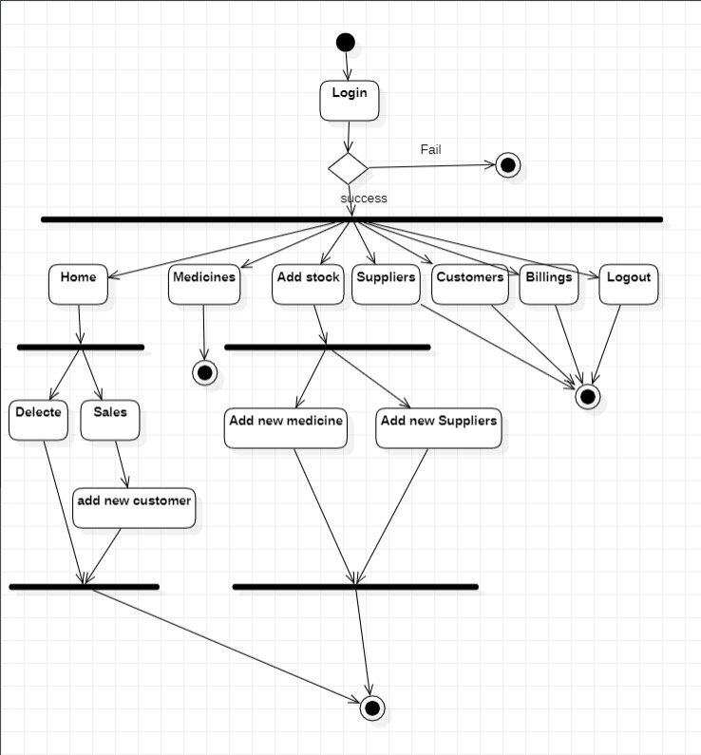

**Sequence Diagram:**

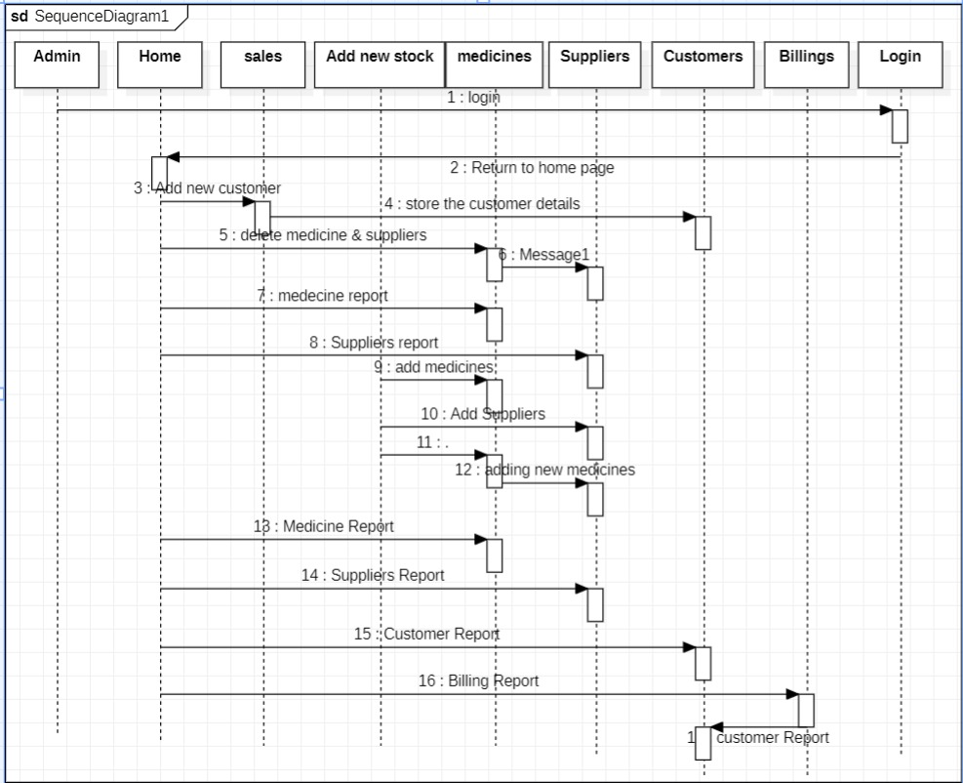

**4.0 User interface design**

User connects through the webpage <http://localhost/PMS>.

* Login Page
* Home Page
* Sales Page
* Add Customer Page
* Add Stocks Page
* Medicines Page
* Suppliers Page
* Customers Page
* Billings Page
* Logout Controller

**4.1 Description of the user interface**

* **Login Page:**
* Admin needs to enter the email address and password.

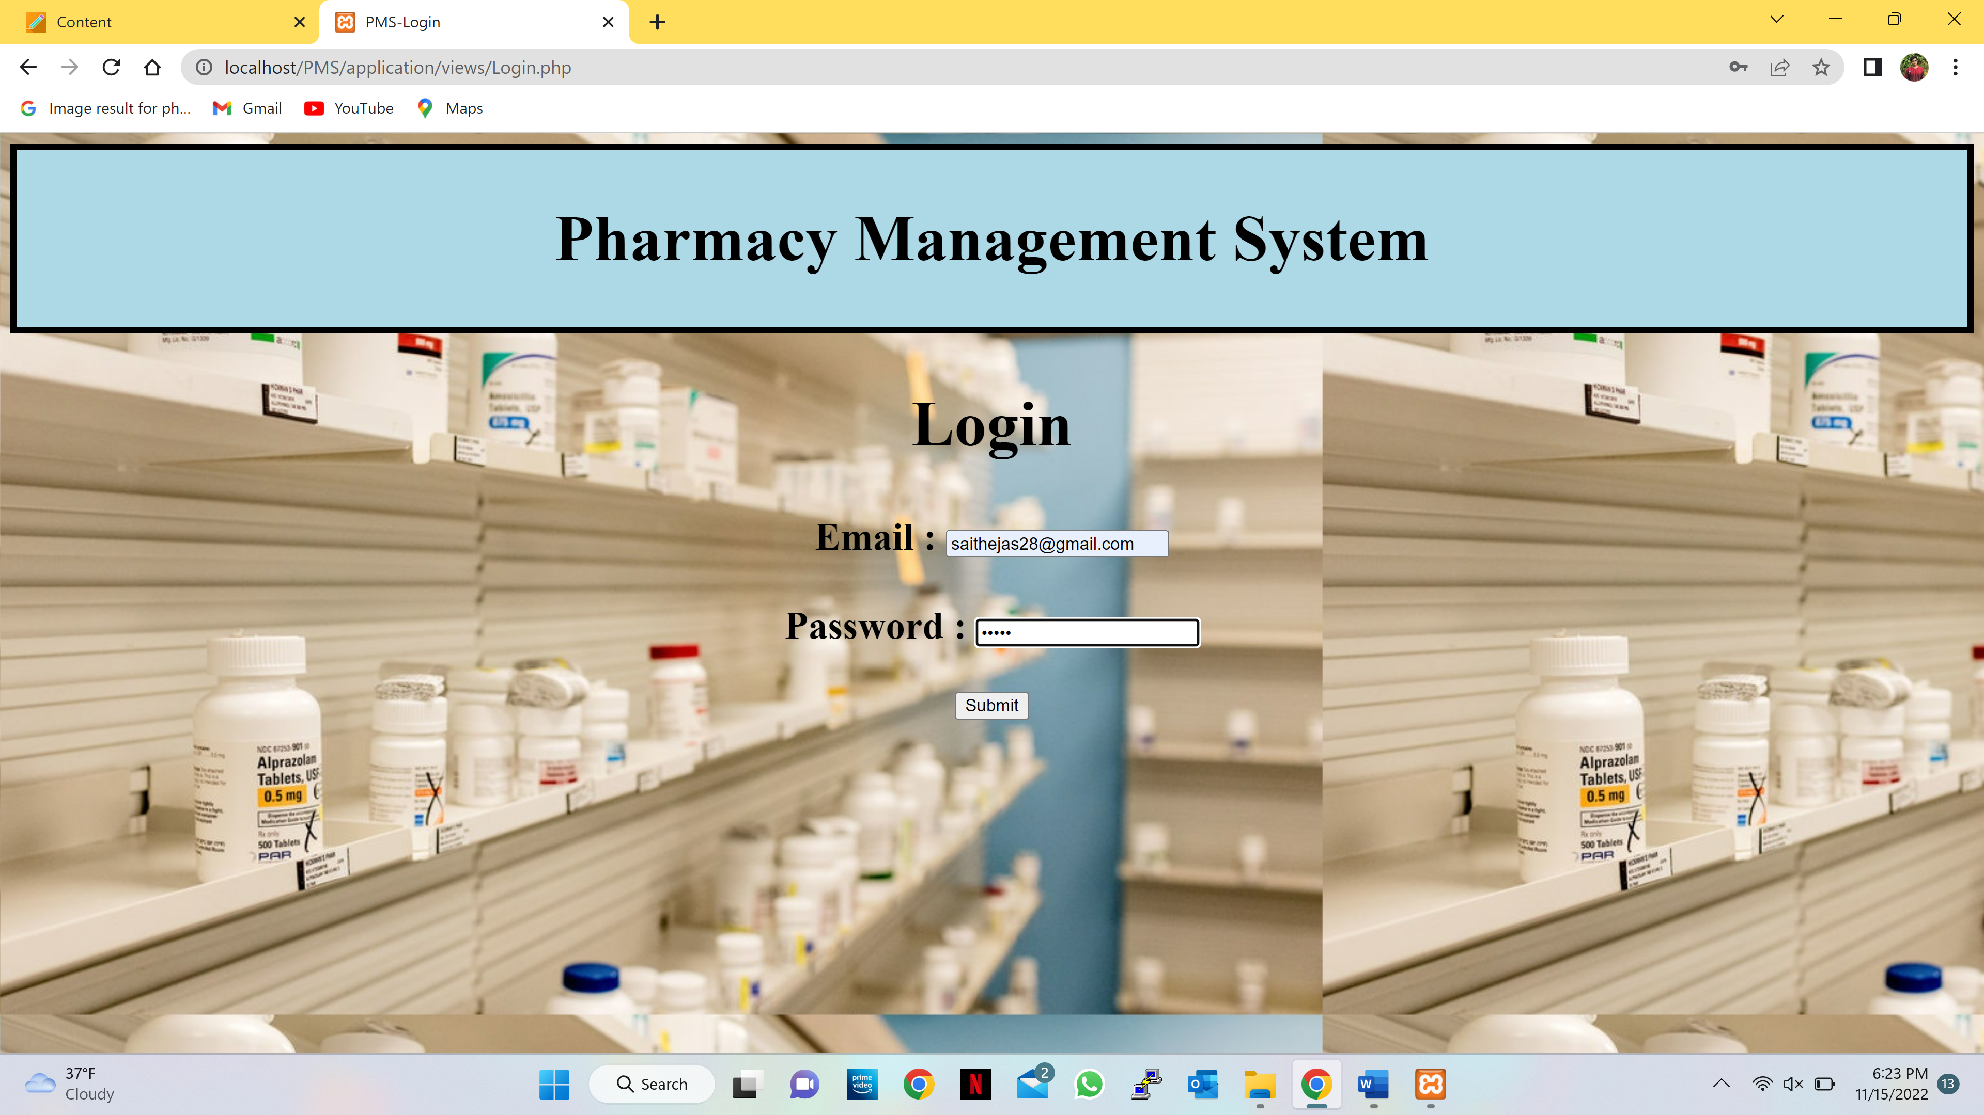

* If the admin enters the incorrect email address or password it displays a dialog if the admin selects ok it takes back to the Login page .

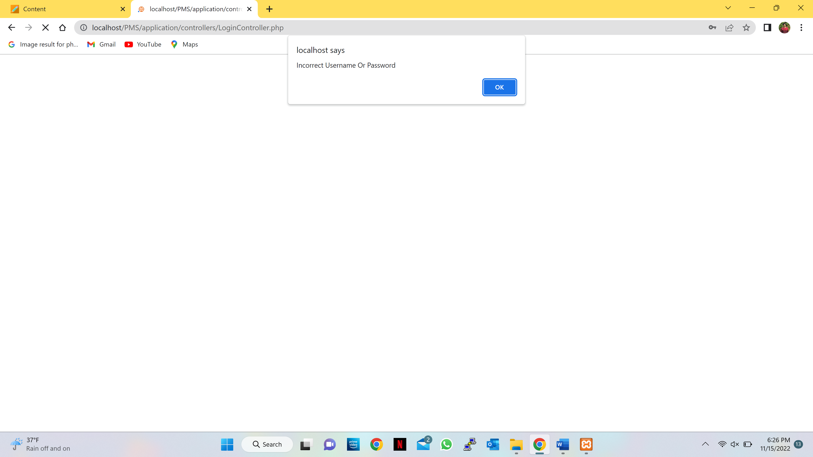

* If the admin enters the correct email address and password it gives an success message in the dialog.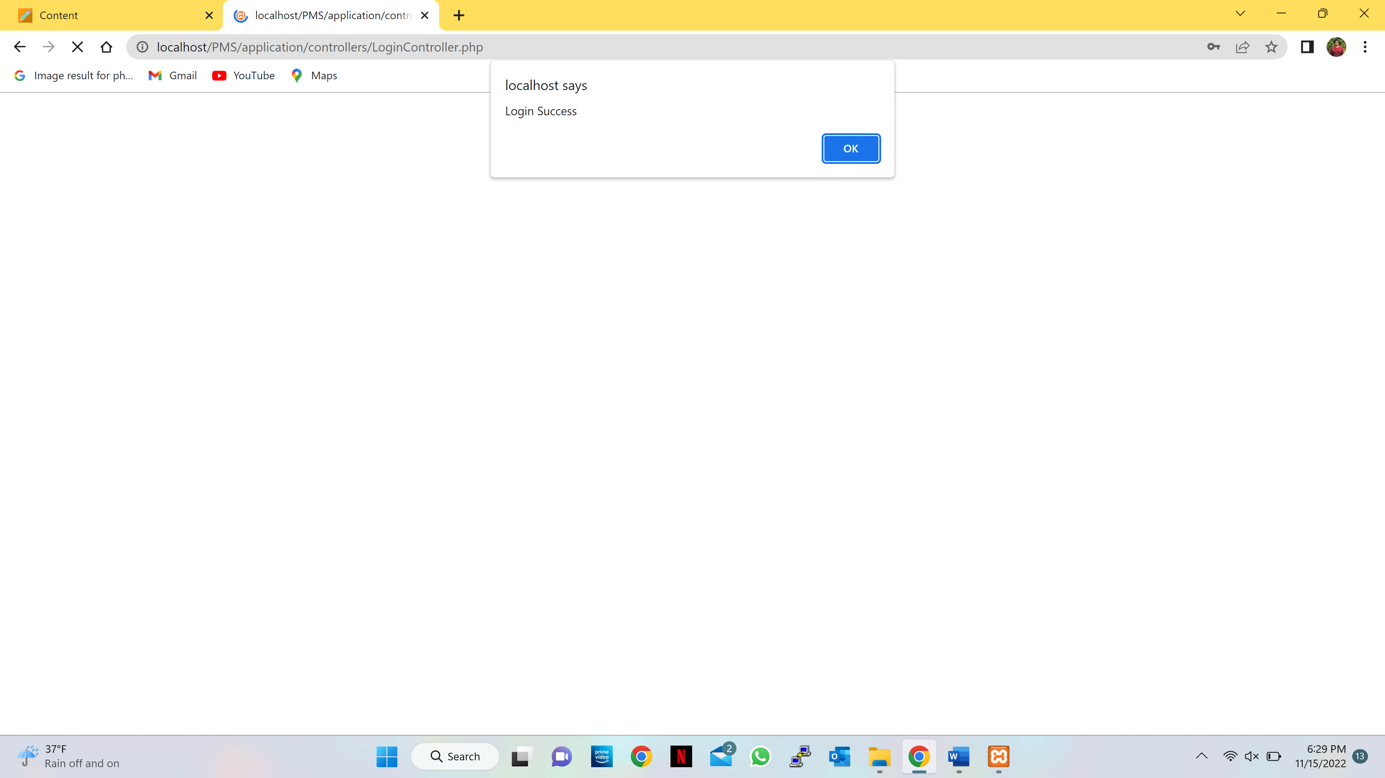
* After the success dialog it moves to the home page.
* **Home Page:**

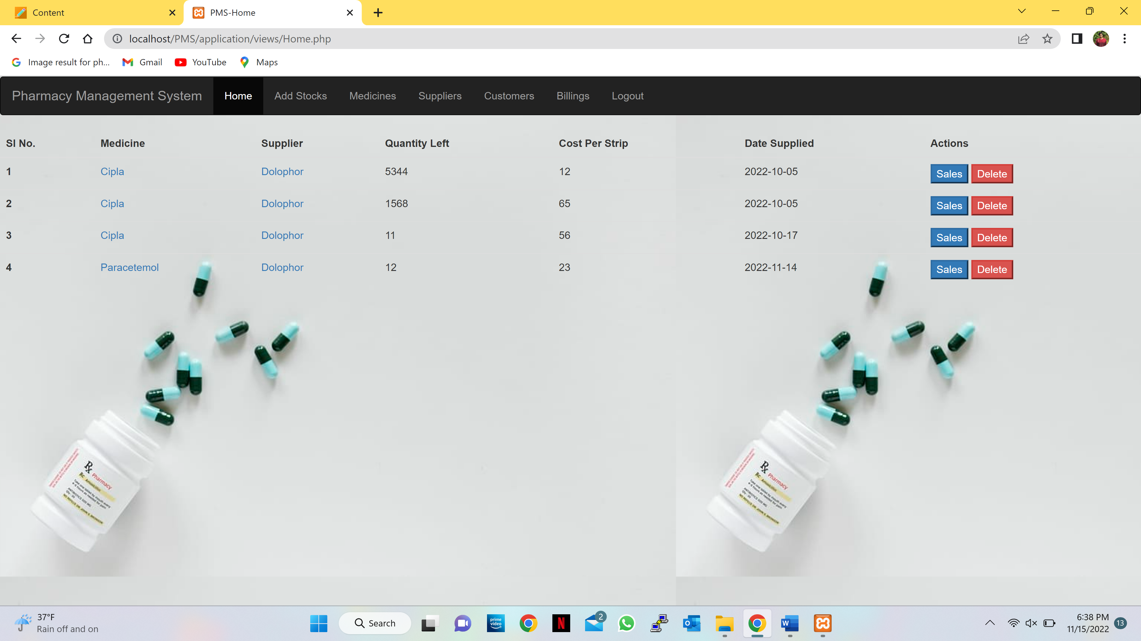

* The admin can see the available stock of medicines.
* The admin can delete the unavailable or expired medicines.
* The admin can go to the respective sales page by clicking the sales button respective to the medicine.
* **Sales Page:**

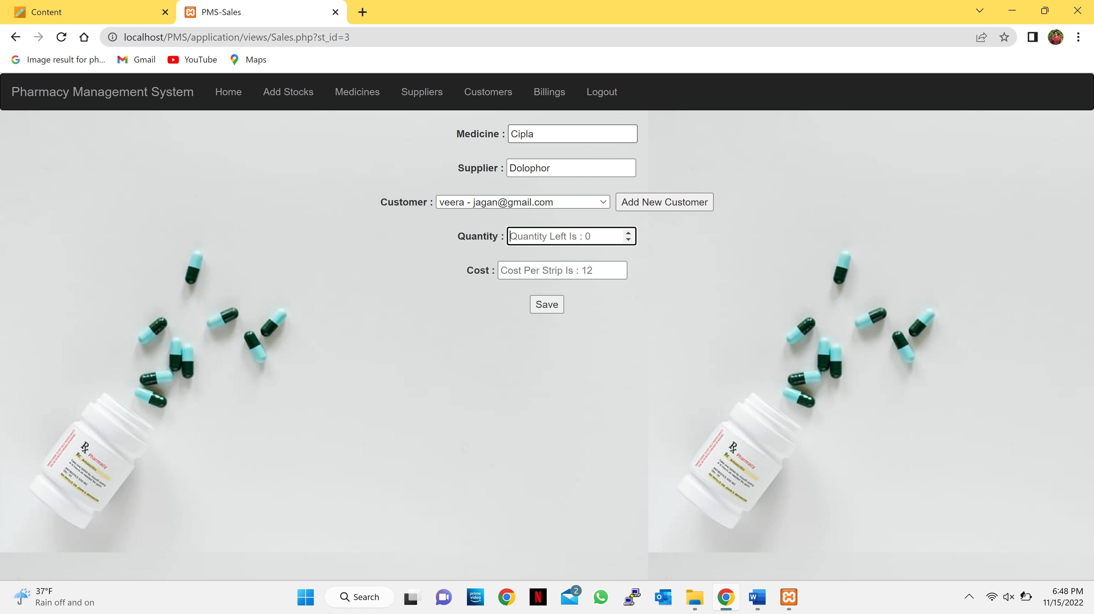

* If the stock is empty it will give you a dialog quantity left is 0.

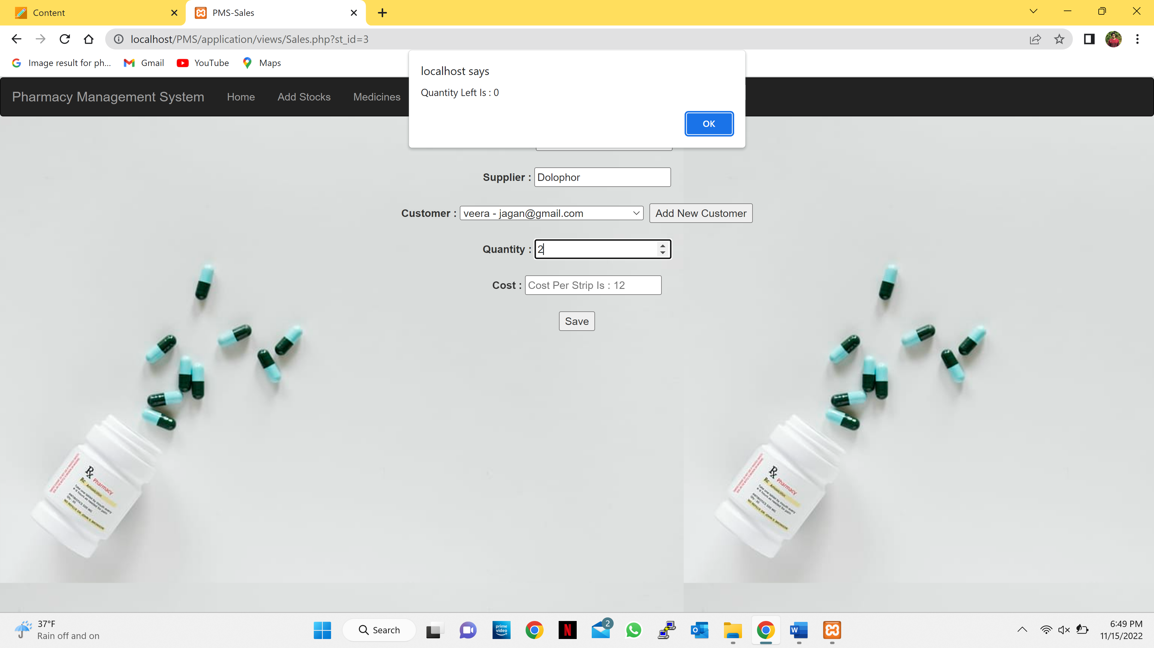

* If the stock is available admin can store the details of customer and how many medicines he is buying.

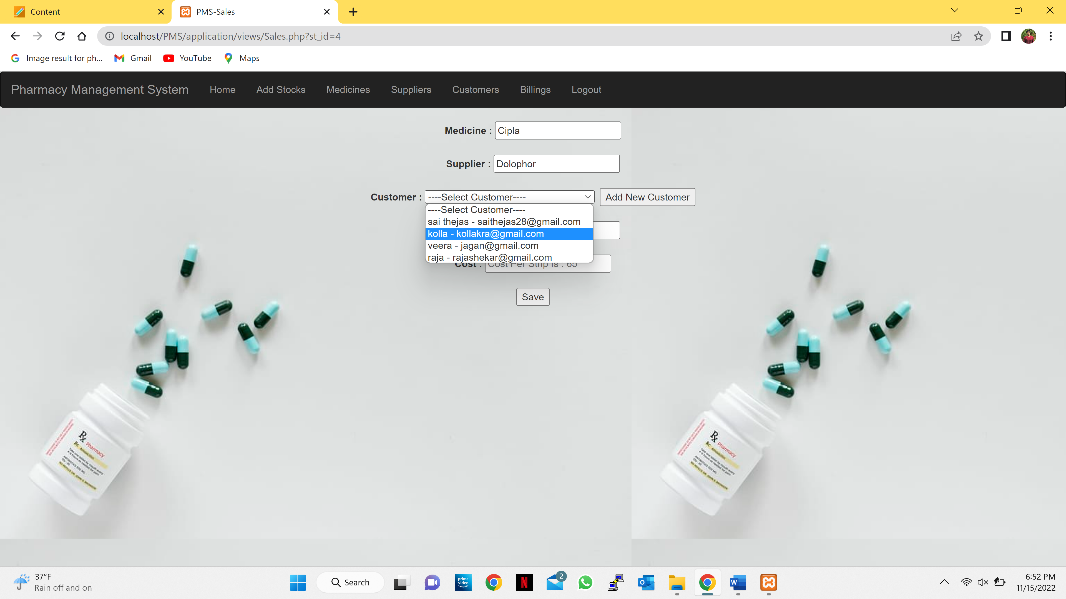

* If the customer is new, then the admin can store the customer’s detail by clicking the Add New Customer button which further takes to add customer page.
* **Add Customer Page:**
* Admin enters the details of customer and selects the add button.

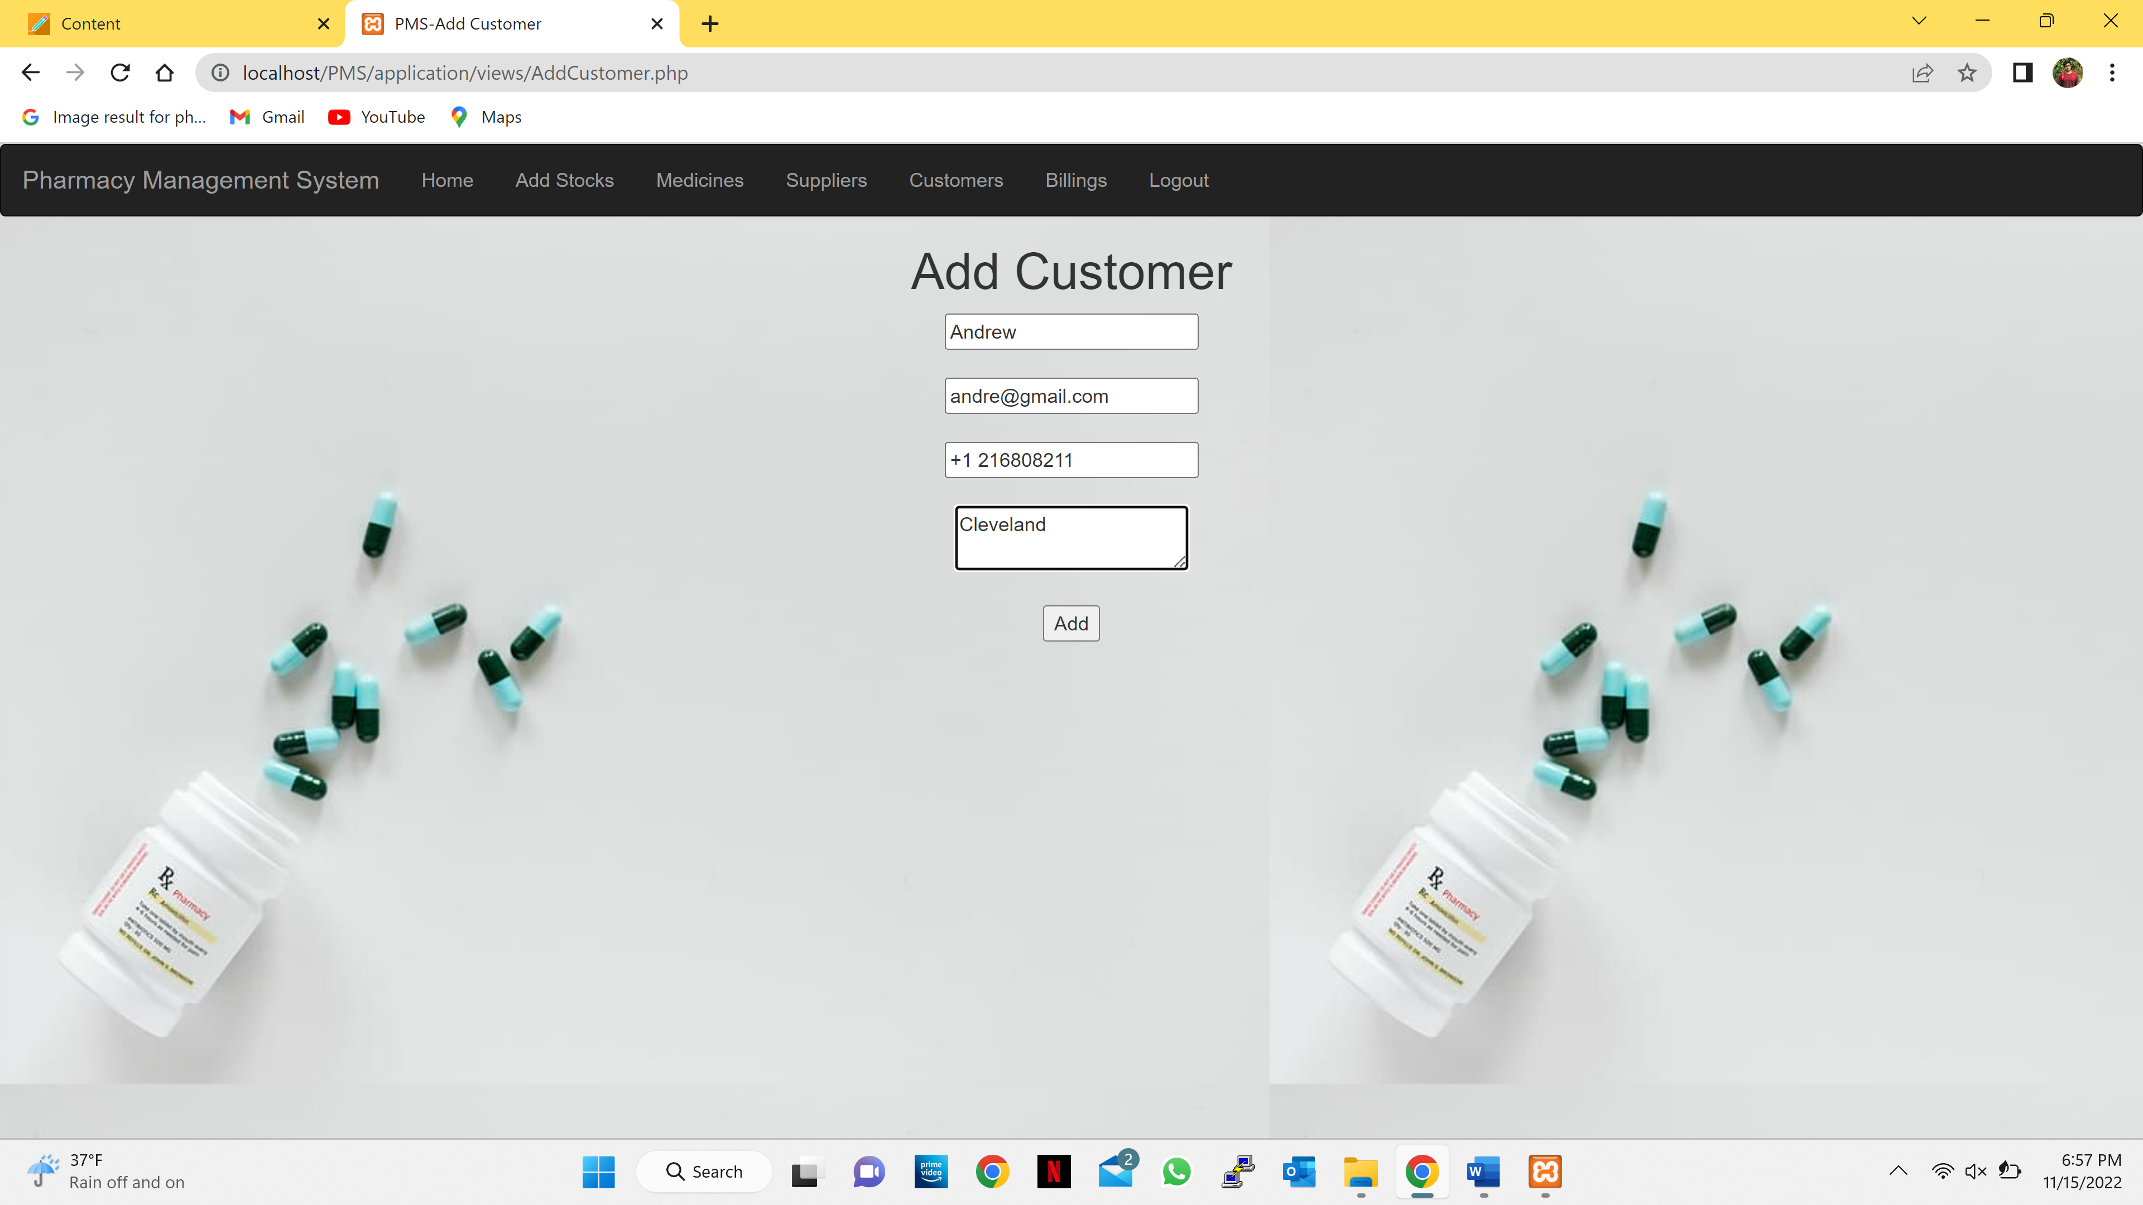

* As soon the admin selects the add button it gives an success message and takes back to the add customer page.

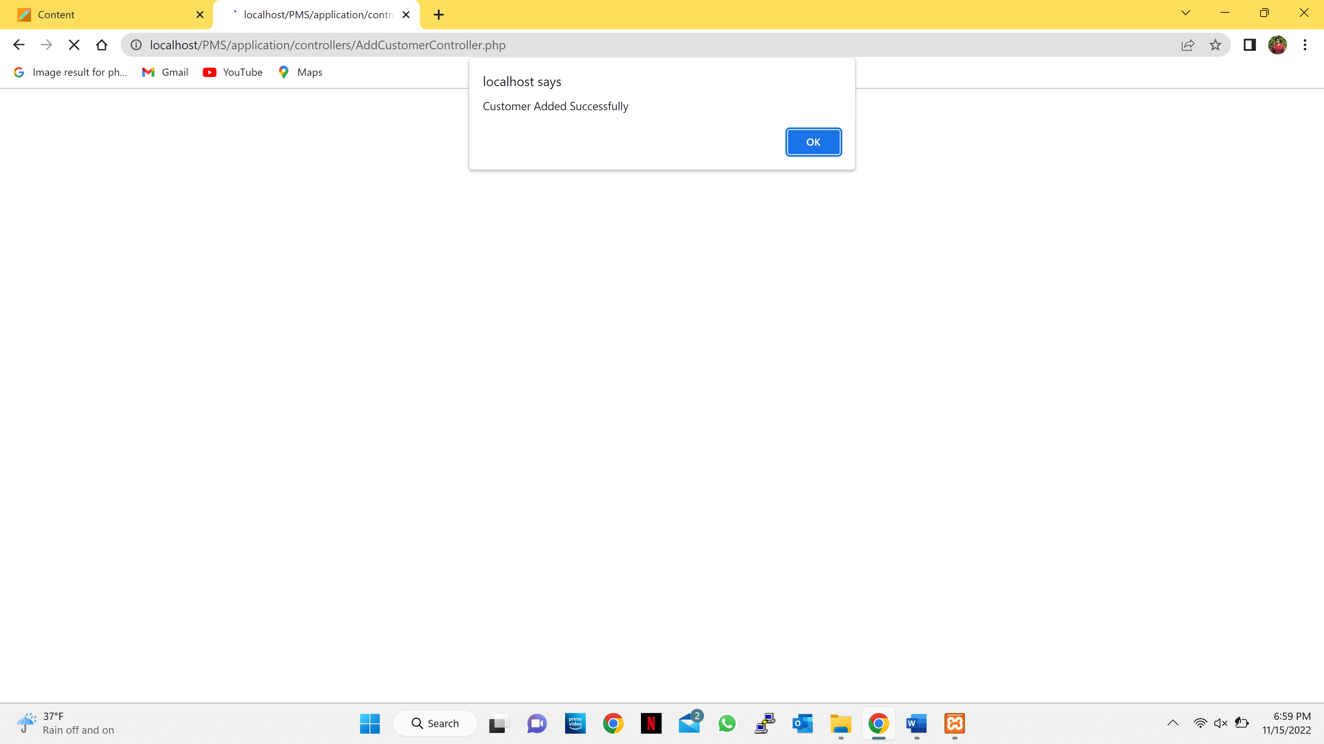

* Admin can add new medicine details by clicking the add new medicine button it moves to add medicine page.

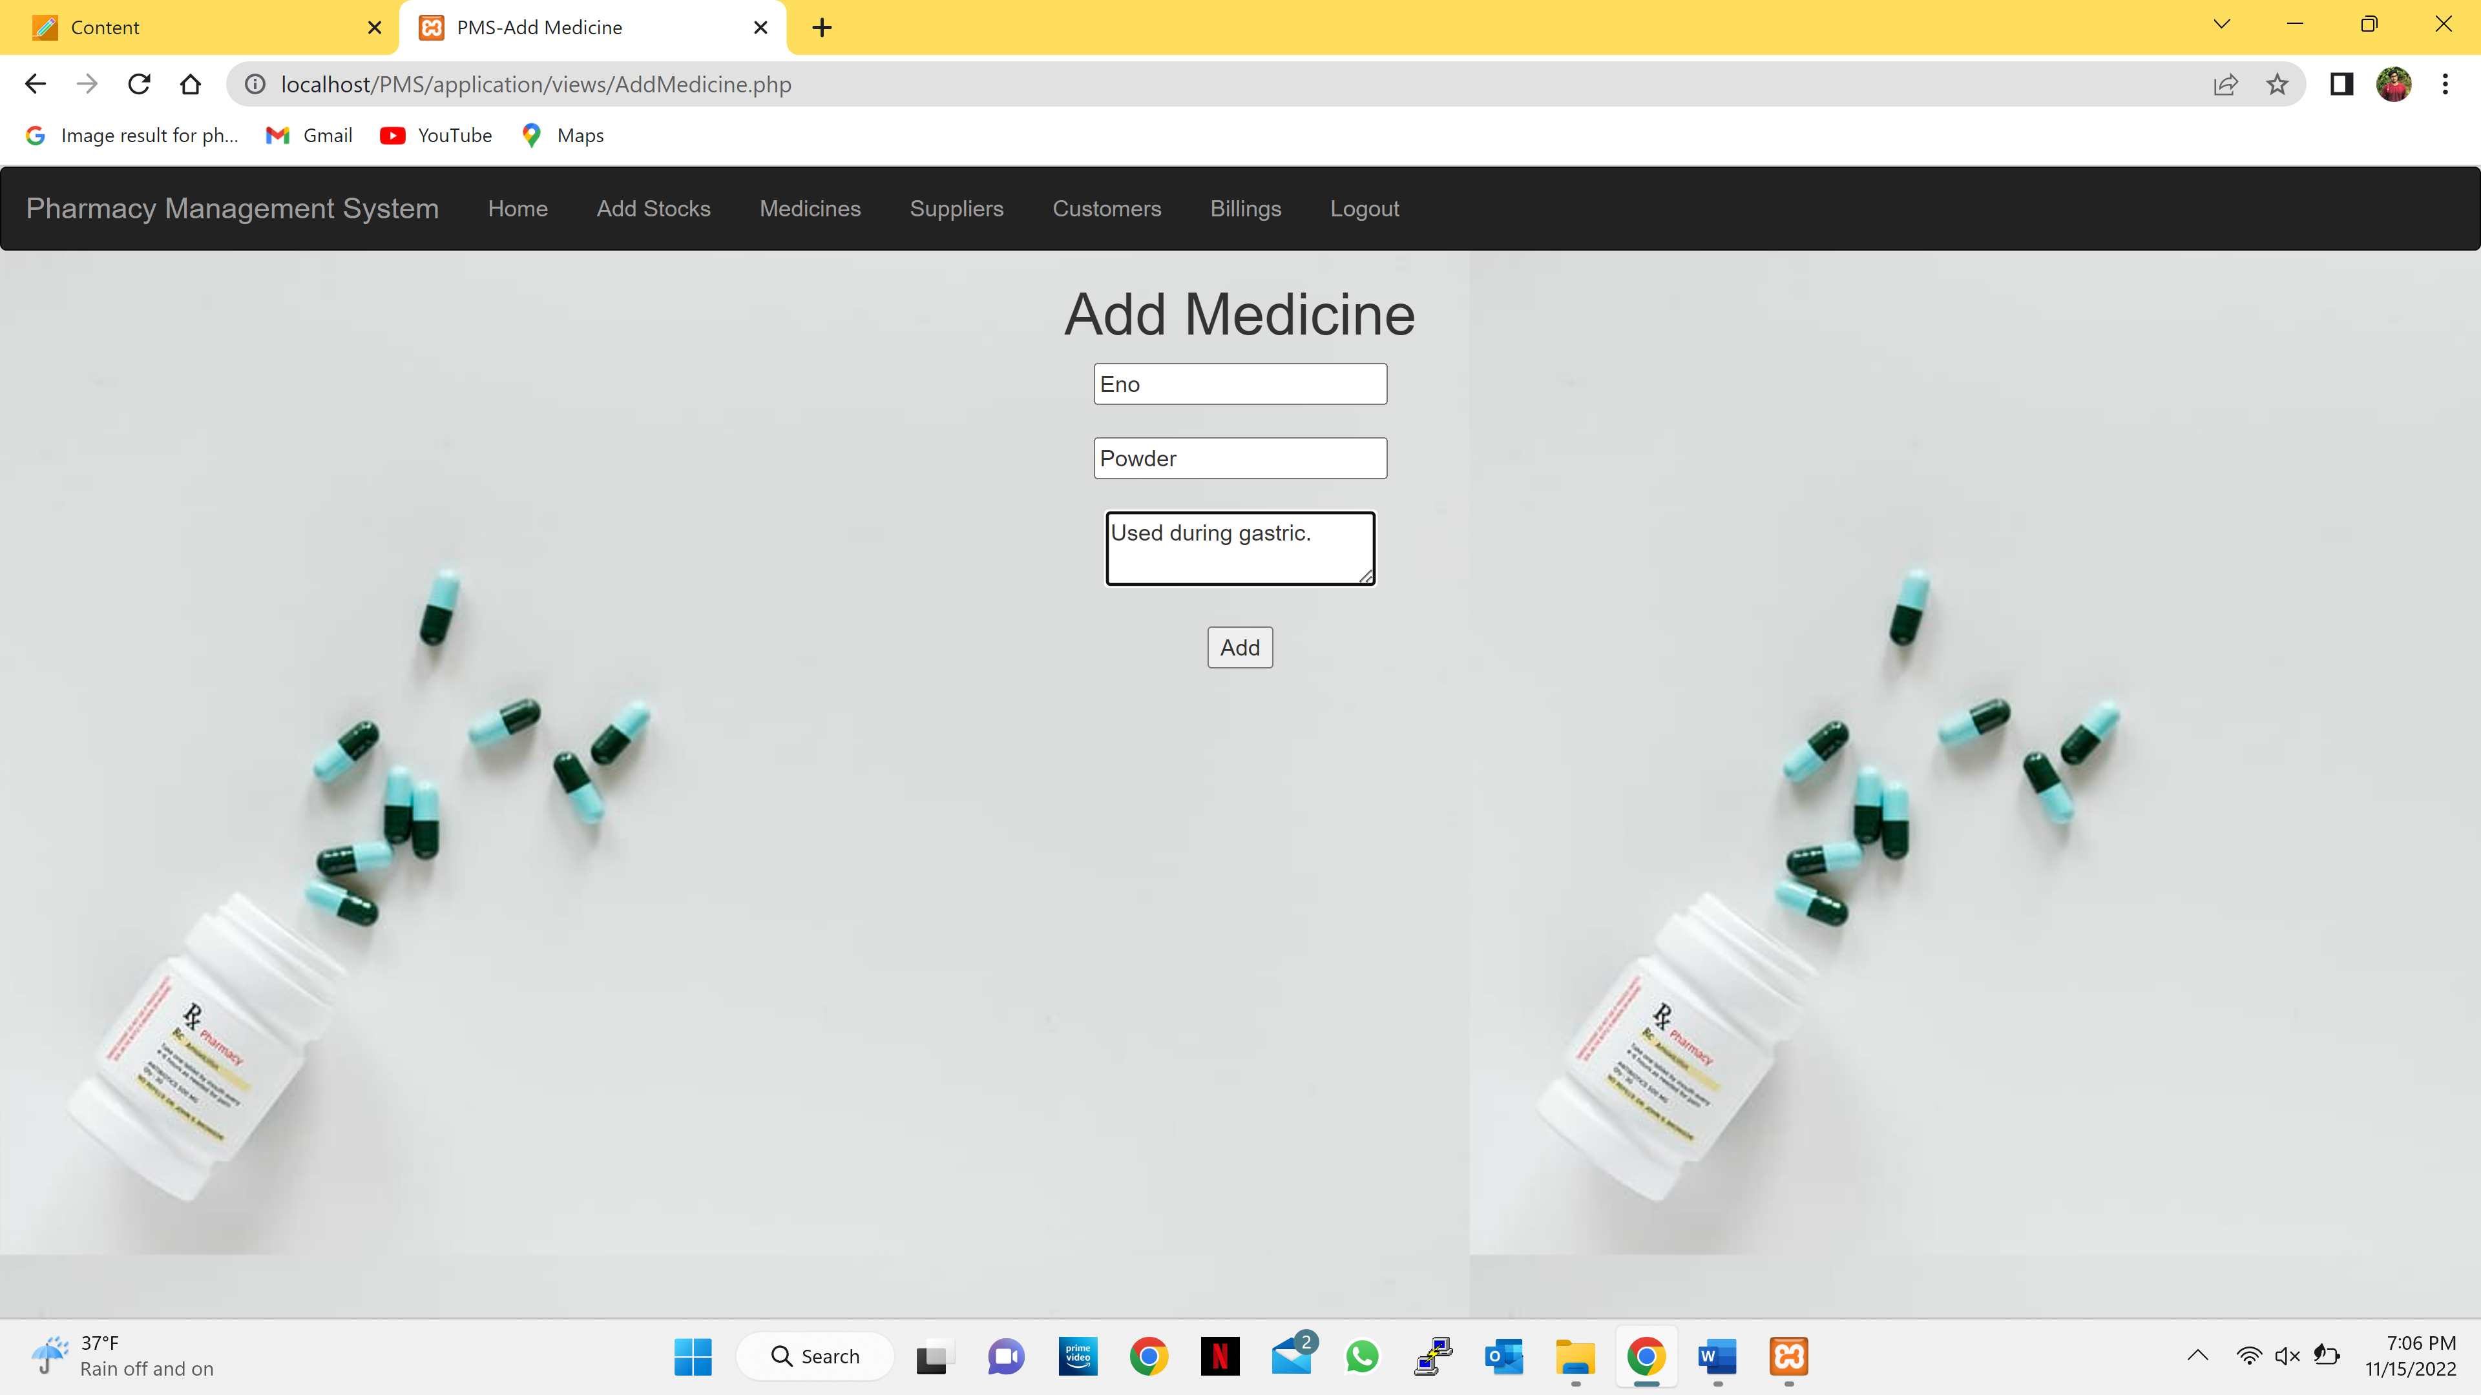

* Admin can add new supplier details by clicking the add new button it moves to add supplier page.

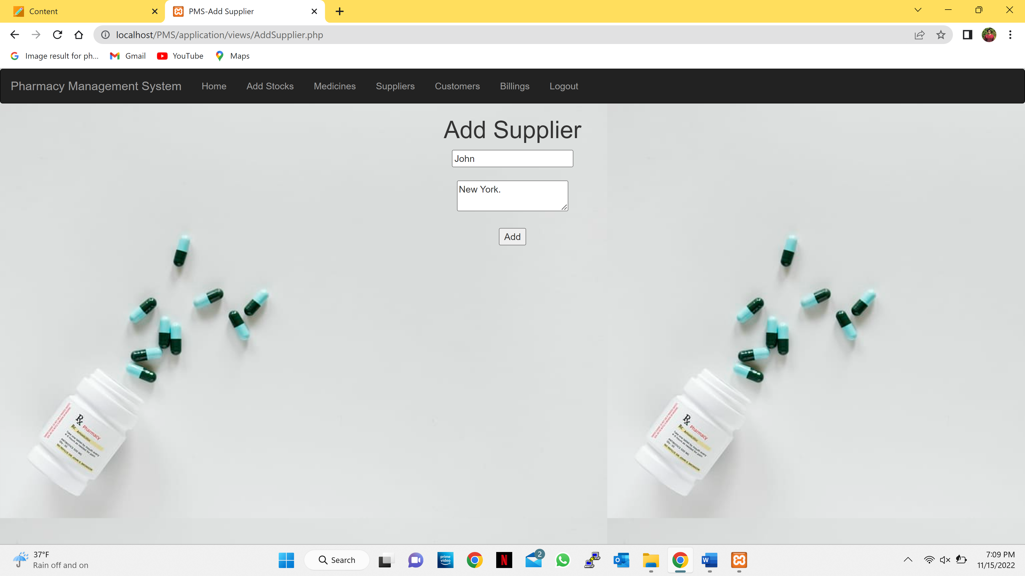

* **Add Stocks Page:**
* Admin can select the medicine and supplier, enter the quantity received cost per strip and change the date received.

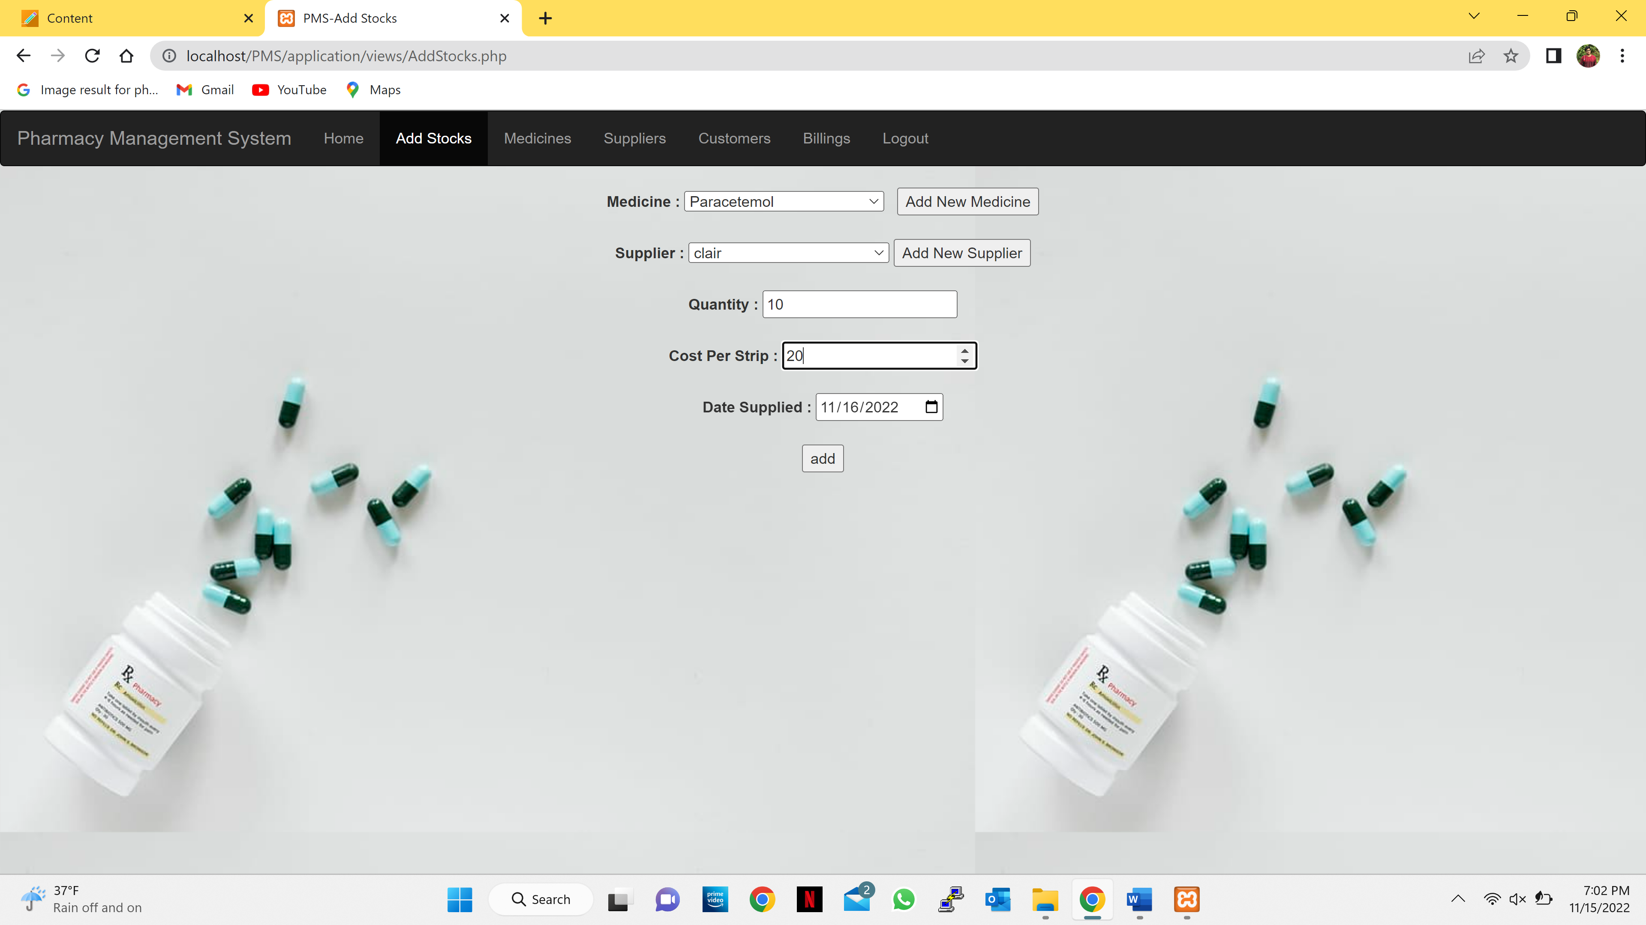

* After the admin enters the stock details and select the add button it will display a successful message.

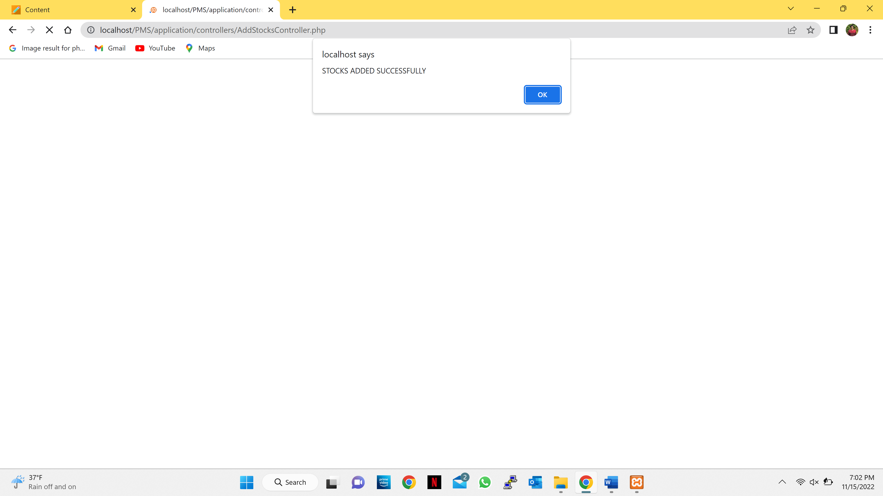

* **Medicine Page:**

Admin can see the available medicines in the store.

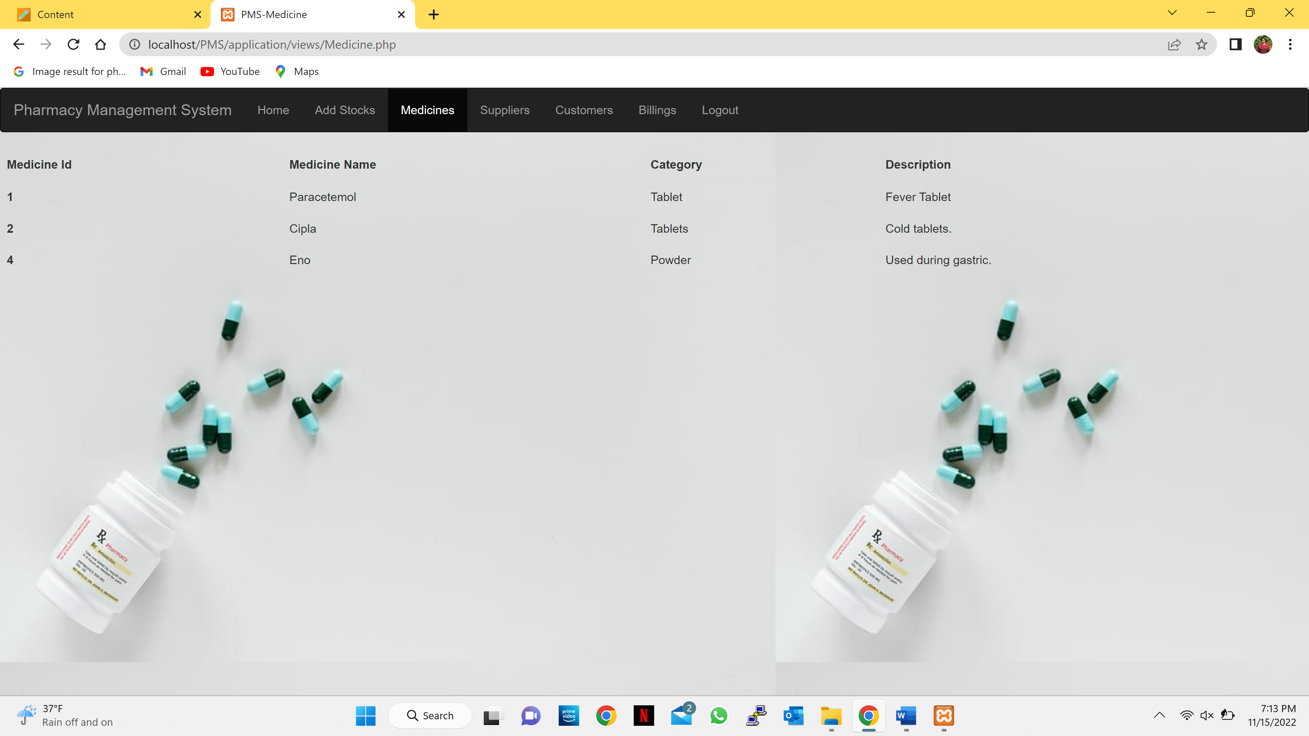

* **Supplier Page:**

Admin can see the supplier details.

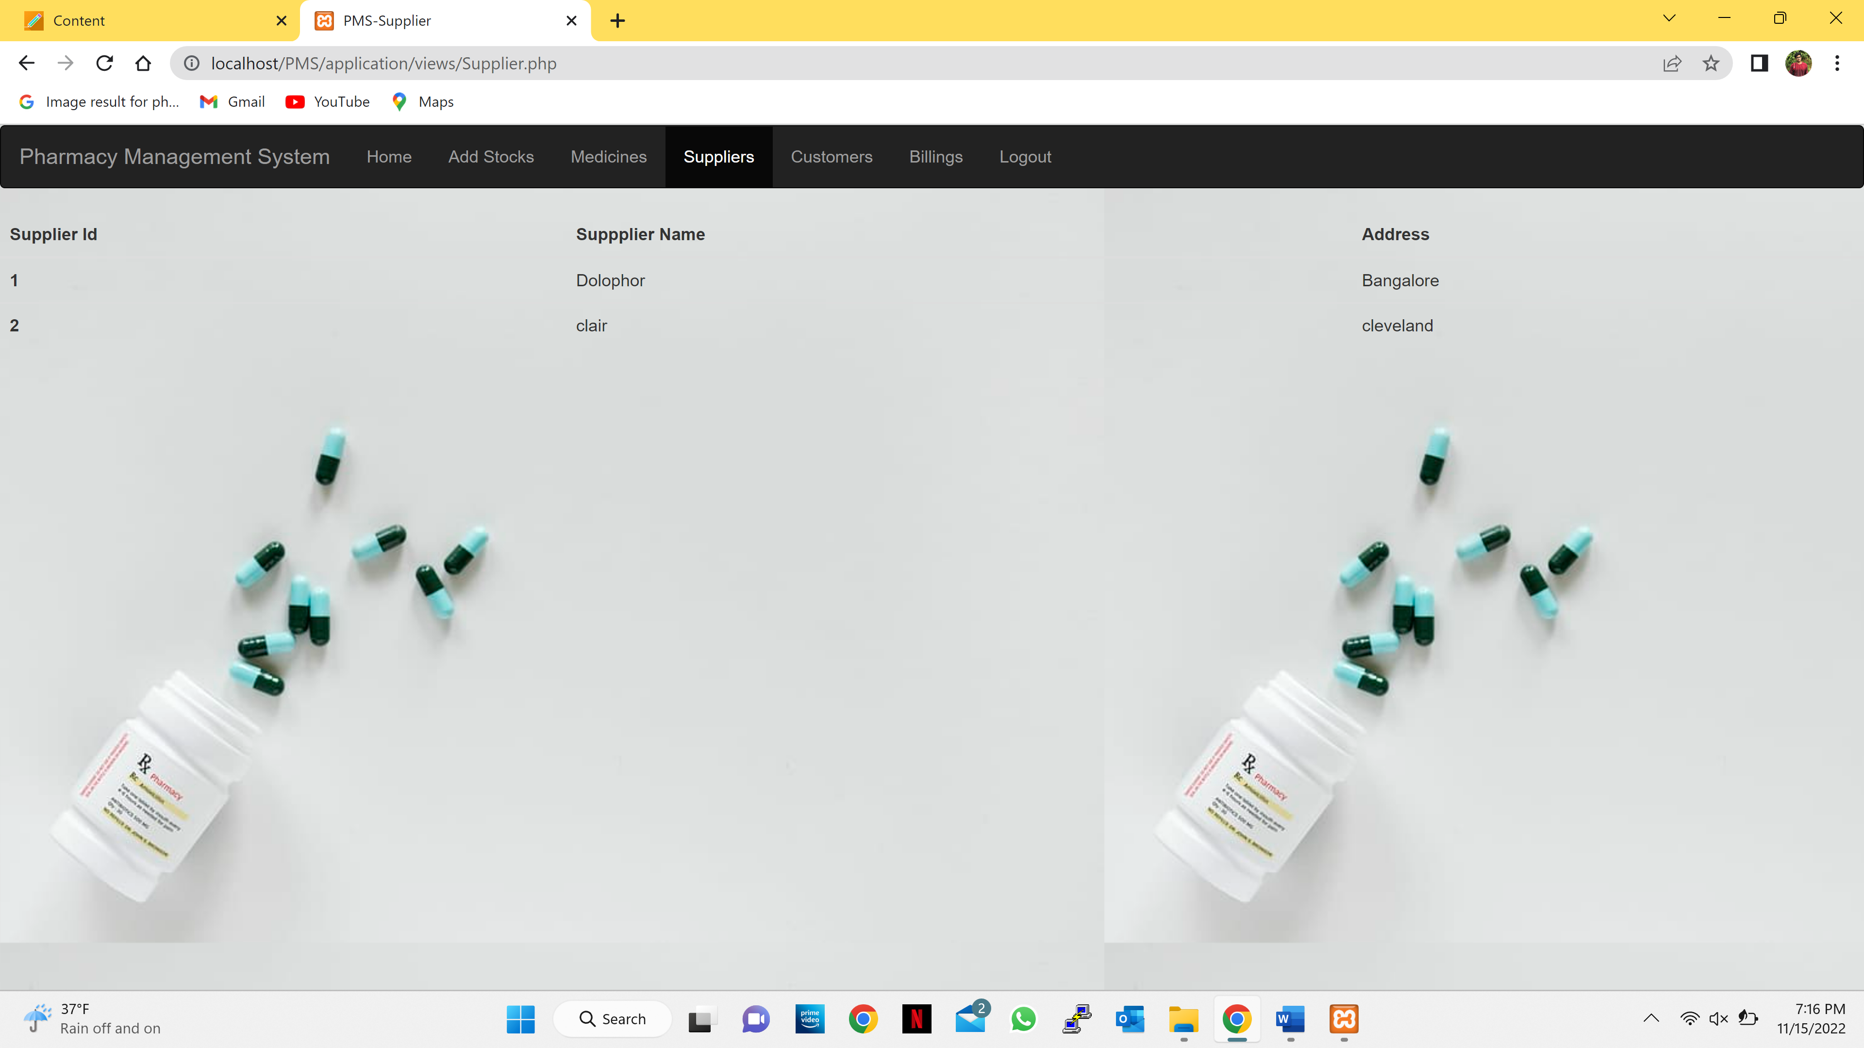

* **Customers Page:**

Admin can see the customer details.

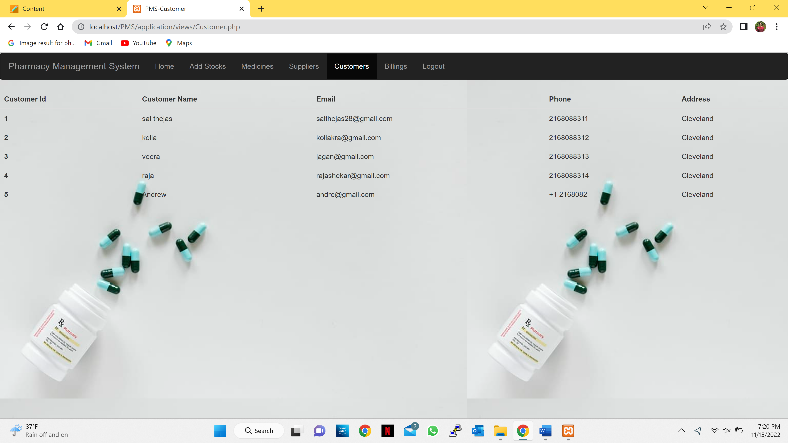

* **Billings page:**
* Admin can see all the billings.

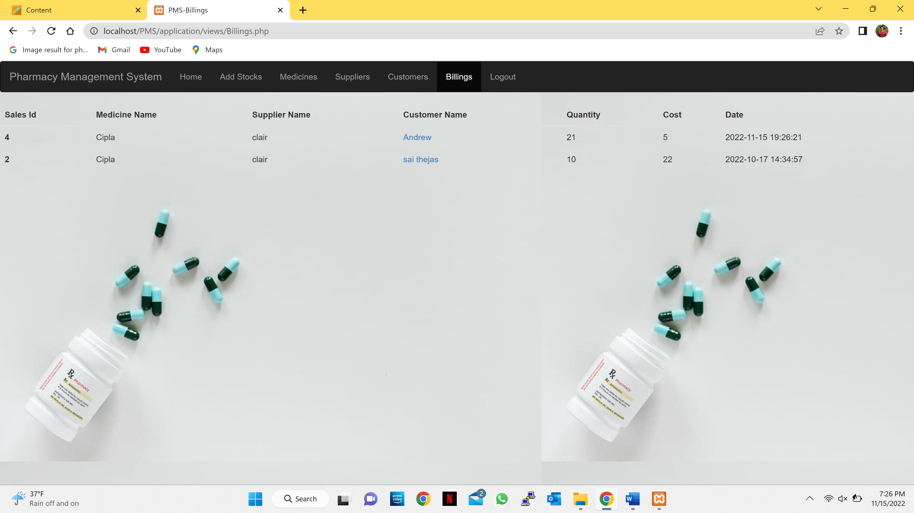

* Admin can also see the customer details individually by clicking on the name of the customer.

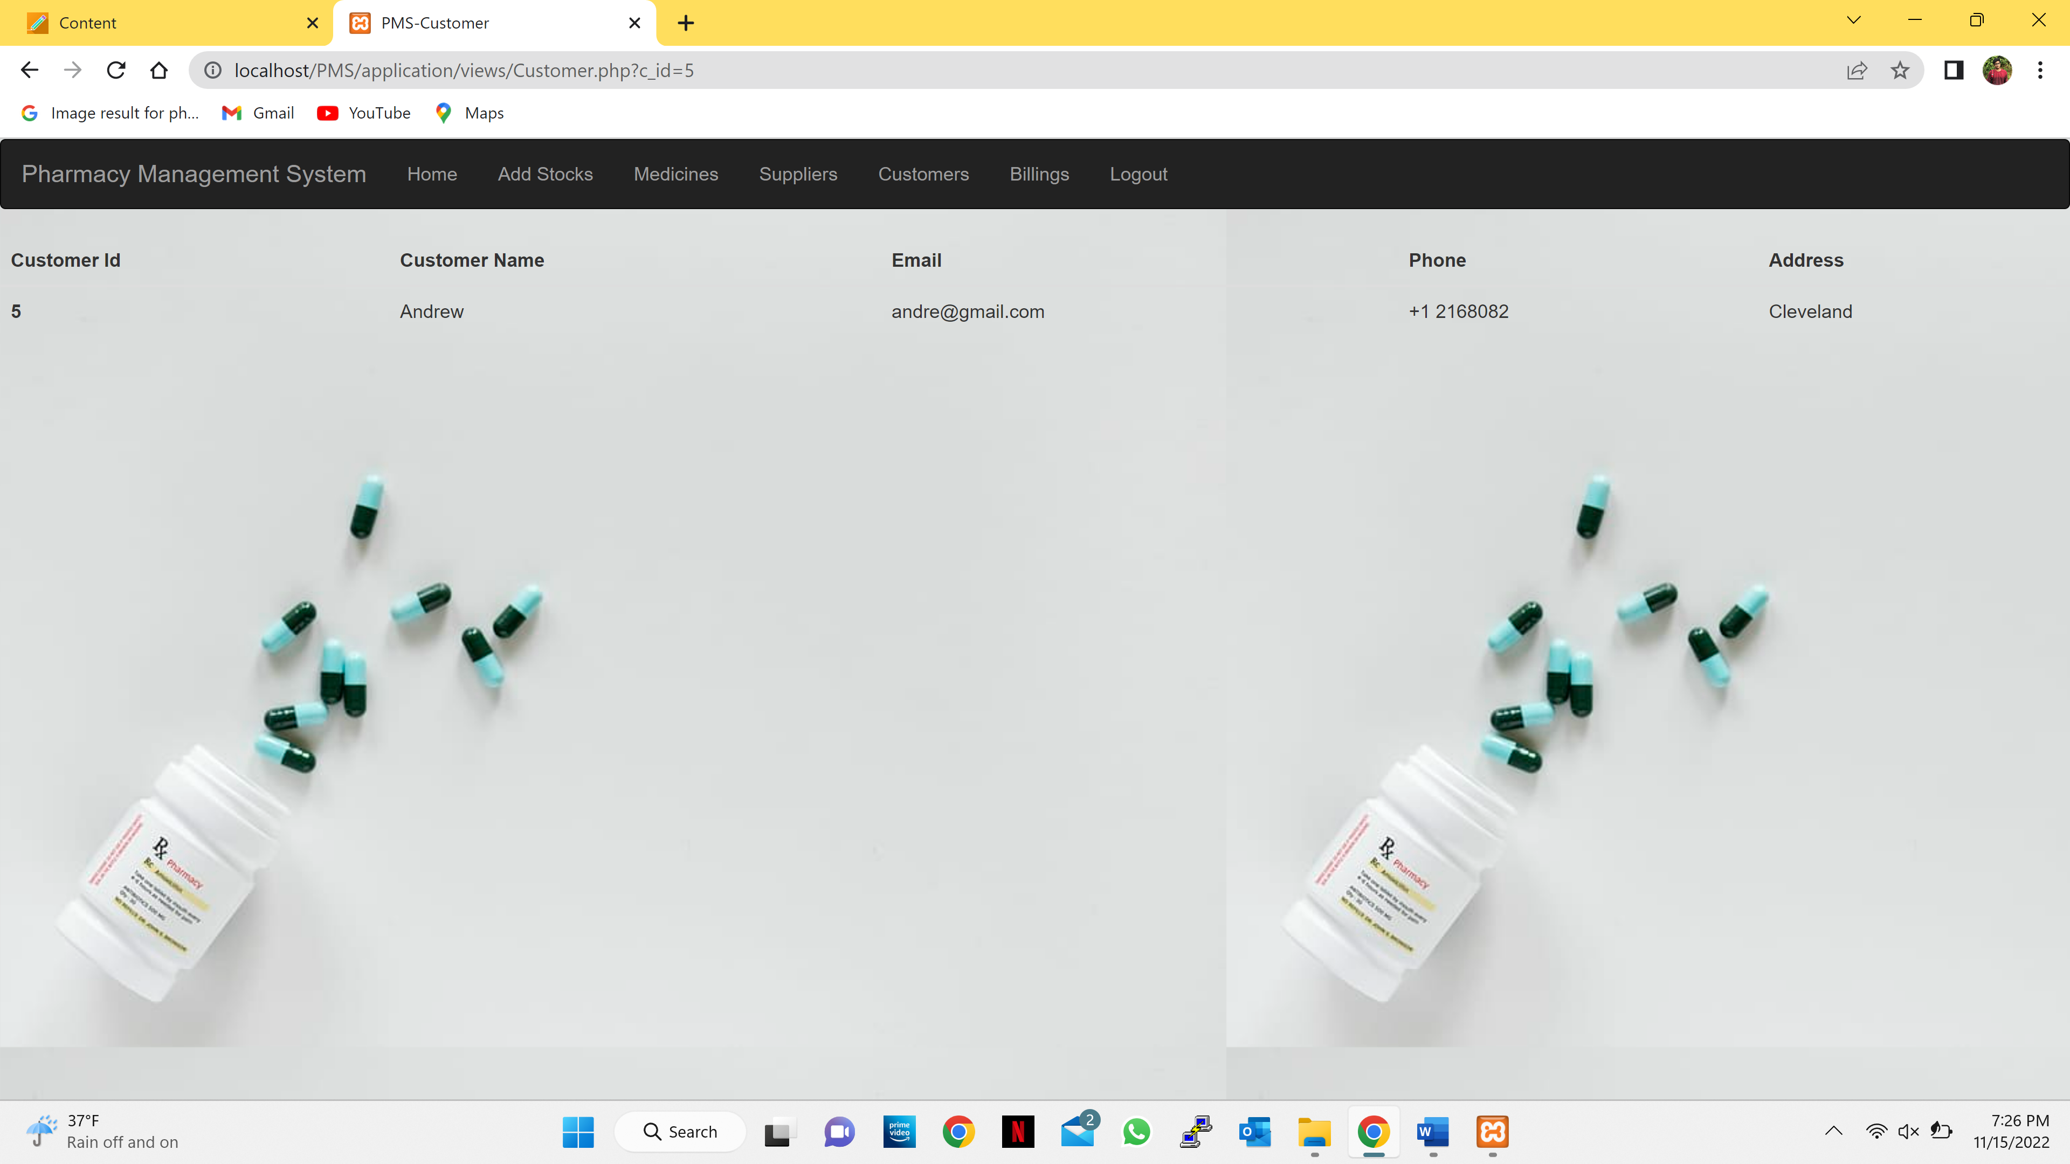

* **Logout:**
* After admin clicks logout, it will ask for confirmation for logging out.

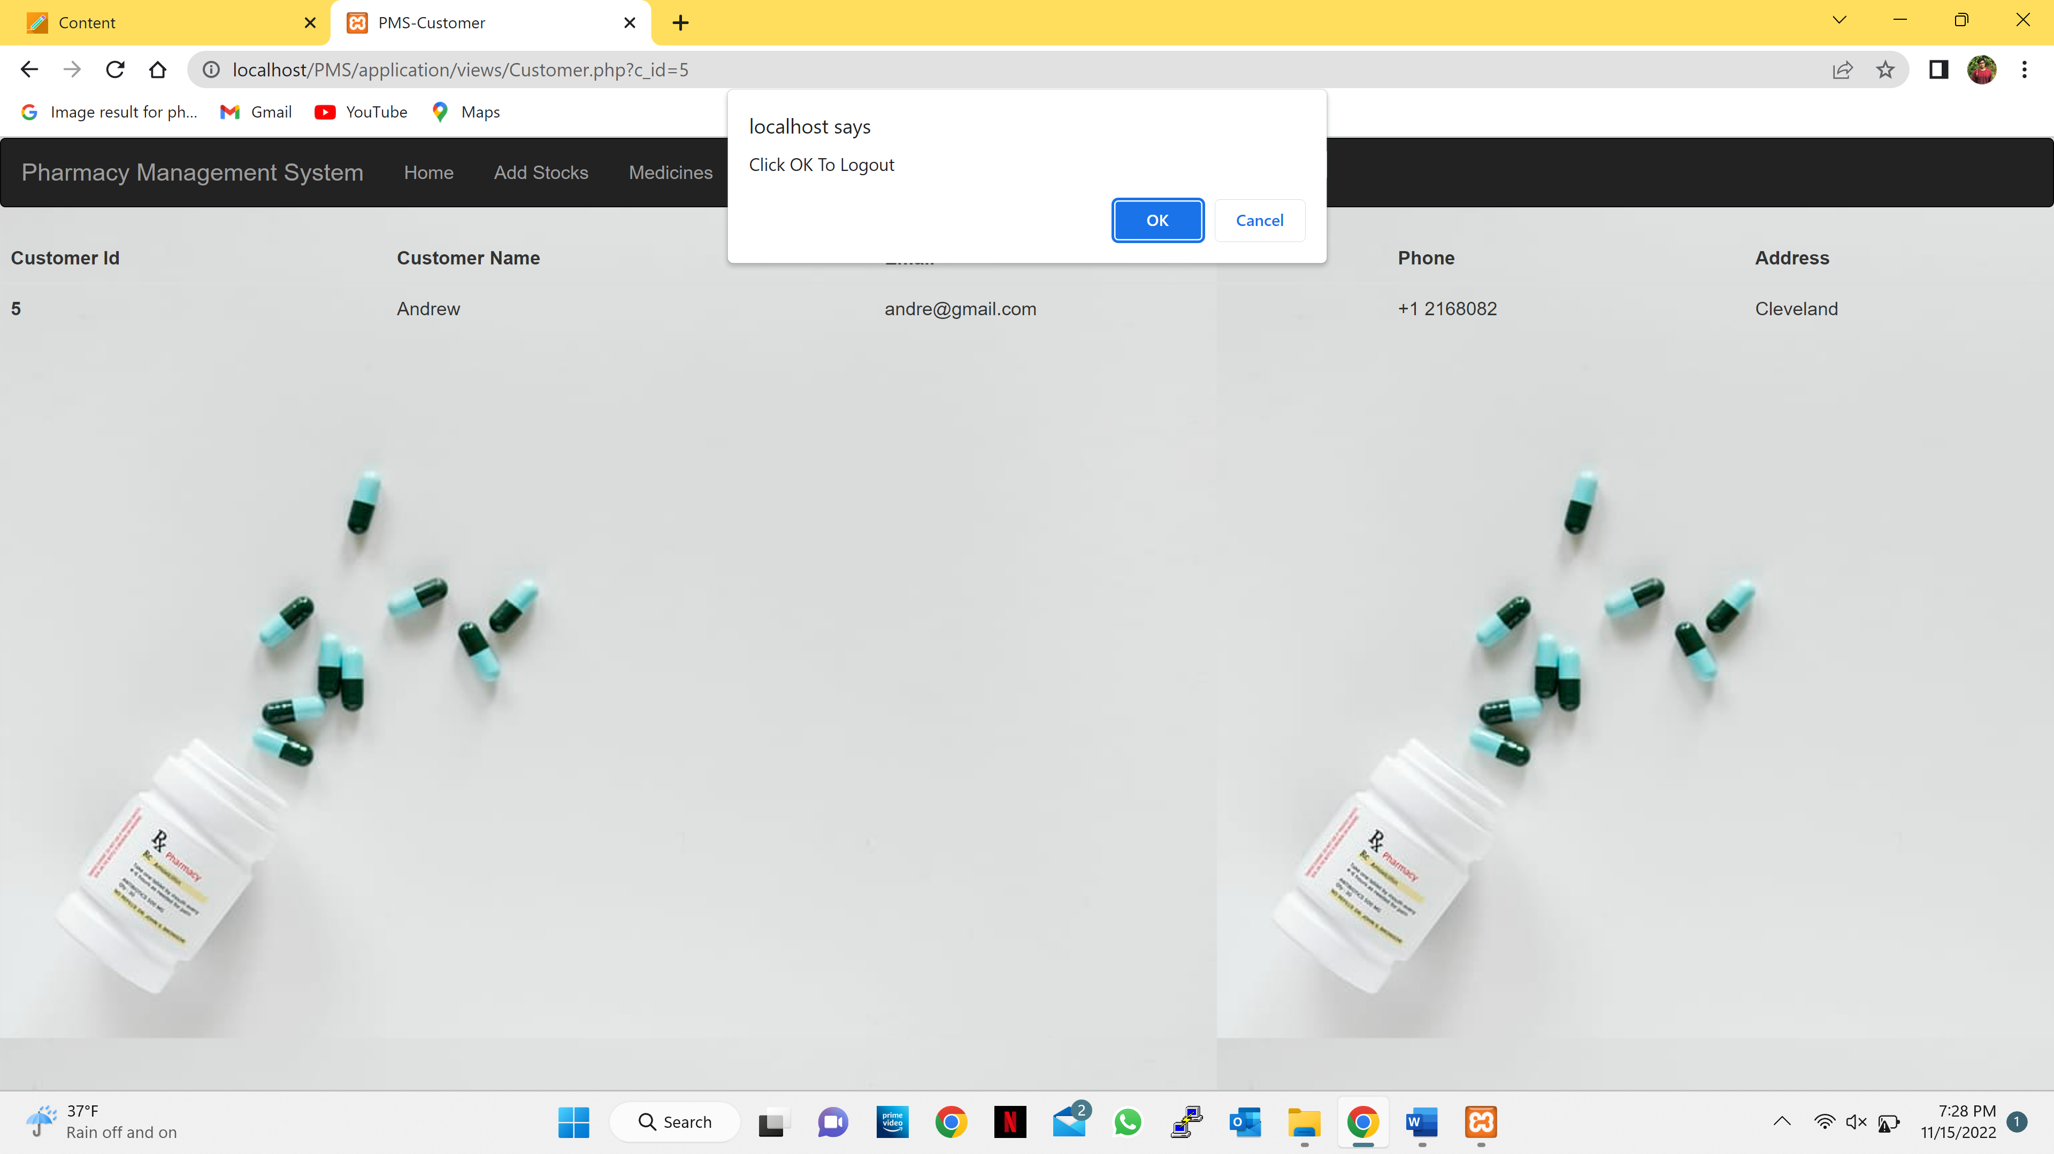

* After the admin selects the ok button, it will display an success message in dialog.

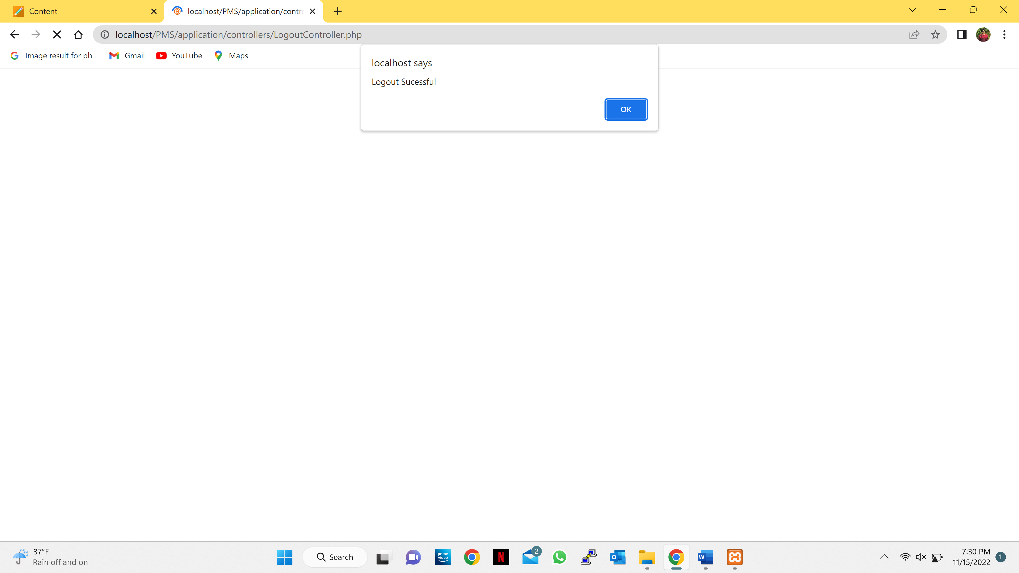

* After the admin selects the ok button, it will move back to the login page.

**4.2 Interface design rules**

While developing the web page we customized many times to get an easy understandability for the Admin to access the web page navigating them into right directions with a minimum amount of accessibility buttons and interferences that helps the admin to keep to track with the stocks available throughout the web page.

**5.0 Restrictions, limitations, and constraints**

**Limitations:**

* It’s accessible to local users only.
* This application can be used by only one person at a time.

**Restrictions:**

* This application is used only by the business end not for the customer end.

**6.0 Appendices**

**6.1 Requirements traceability matrix**

|  |  |  |  |  |  |  |  |
| --- | --- | --- | --- | --- | --- | --- | --- |
| Login Page | Home Page | Add Stock Page | Medicine Page | Supplier Page | Customer Page | Billing Page | Logout Button |
| Admin must enter correct username and password | Display of the stocks and has two buttons to add billing or delete the medicine | Admin can add the details of a medicine by entering the medicine name, Medicine category and Medicine description. Admin can also add a new supplier detail. | It is report page consisting of all the medicines available displaying the medicine Id, Medicine name, Medicine category and Medicine description. | It is report page consisting of all the Suppliers details displaying the Supplier Id, Supplier name and Supplier address. | It is report page consisting of all the customer details displaying the Customer Id, Customer name, Customer E-mail address, Customer phone number and Customer Address. | It will display the details of the stock sold and the customer details who buys the stock. | If the admin clicks on the logout button it returns to the login page. |

**6.2 Implementation issues**

* **Growing complexity in landscape:** We alluded to this earlier. As the database market evolves, many companies are finding it difficult to evaluate and choose a solution. There are relational databases, columnar databases, object-oriented databases, and NoSQL databases. Not to mention the plethora of vendors offering their own spin on each.
* **Limits on scalability:** The fact is, all software has scalability and resource usage limitations, including database servers. Forward thinking companies concerned about transaction processing capacity know that cataloging components, database architecture, and even operating systems and hardware configuration all affect scalability.
* **Increasing data volumes:** As the amount of data generated and collected explodes, companies are struggling to keep up. Research shows that we’ve created more data in the past two years than in the entirety of the human race. Yet, a 10% increase in data accessibility could generate more than $65 million additional net income for a typical Fortune 1000 company.
* **Data security:** Databases are the hidden workhorses of many companies’ IT systems, storing critical public and private data. Lately there has been an understandable and high-profile focus on data security. A data breach typically costs a company $4 million, not to mention loss of reputation and goodwill.
* **Decentralized data management:** Although there are benefits to decentralized data management, it presents challenges as well. How will the data be distributed? What’s the best decentralization method? What’s the proper degree of decentralization? A major challenge in designing and managing a distributed database results from the inherent lack of centralized knowledge of the entire database.